**NATIONAL INSTITUTE OF TECHNOLOGY AGARTALA**



**INDUSTRIAL INSTRUMENTATION LAB**

**ELECTRONICS AND INSTRUMENTATION ENGINEERING**

**SUBMITTED BY:**

**GROUP 2:**

**ANKIT KUMAR SINGH 21UEI006**

**MUSKAN GUPTA 21UEI007**

**GOLU KUMAR 21UEI008**

**ASHISH KUMAR 21UEI009**

**ABANTIKA DEB 21UEI010**

**IN THE GUIDENCE OF:**

**DR. RUPAM GUPTA ROY (ASSISTANT PROFESSOR)**

**MR. SURAJ DAS (TECHNICAL ASSISTANT)**

**MR. KAILASH PRATIM PHUKAN (TECHNICAL ASSISTANT)**

INDUSTRIAL INSTRUMENTATION LAB

Electronics and Instrumentation Engineering

National Institute of Technology, Agartala

**National Institute of Technology, Agartala**

|  |  |
| --- | --- |
| Home Automation | Group 2, 5th Semester ,2021-2025 |

**Introduction**

The Smartphone-Controlled Home Automation Project is a cutting-edge integration of technology that empowers users to conveniently control the intensity of LED lights and the speed of a fan from their smartphones. The system employs an Arduino Uno microcontroller, an HC-05 Bluetooth module, an L298N motor driver, and a custom mobile application developed using MIT App Inventor.

Key Features:

* **Remote Control via Smartphone**: With this home automation system, users can remotely control various devices within their home using a dedicated mobile application. The intuitive and user-friendly interface enables easy interaction with the connected devices.
* **LED Intensity Control**: The project allows users to adjust the intensity of LED lights according to their preferences. This feature not only enhances the ambiance but also contributes to energy efficiency by offering variable lighting levels.
* **Fan Speed Regulation**: Users can also conveniently control the speed of a fan using the mobile application. This feature is particularly useful for maintaining optimal comfort and temperature conditions in different scenarios.
* **On/Off Functionality**: The system offers the basic on/off functionality for both LED lights and the fan. Users can remotely turn the devices on or off with a single tap on their smartphones, providing an added layer of convenience and control.
* **Bluetooth Communication**: The communication between the Arduino Uno and the mobile application is established via Bluetooth using the HC-05 module. This wireless communication ensures a seamless connection without the need for physical wires.
* **MIT App Inventor Application**: The mobile application is created using MIT App Inventor, a user-friendly visual programming platform. This enables developers to design a customized interface and define the functionality of buttons and sliders that interact with the connected devices.
* **L298N Motor Driver Integration**: The L298N motor driver plays a pivotal role in controlling the speed of the fan. It ensures smooth and reliable fan speed adjustments based on the user's inputs.

How it Works:

* The Arduino Uno is the central controller that manages the communication between the HC-05 Bluetooth module and the connected devices.
* The HC-05 module is paired with the user's smartphone, establishing a secure Bluetooth link.
* The MIT App Inventor application on the smartphone connects to the HC-05 module. The application's interface consists of sliders for LED intensity control, fan speed adjustment, and buttons for on/off control.
* User inputs from the sliders and buttons on the application are transmitted via Bluetooth to the Arduino Uno.
* The Arduino Uno processes the received data and adjusts the PWM (Pulse Width Modulation) signals to control the intensity of the LEDs and the speed of the fan.
* The L298N motor driver interfaces with the fan, translating the PWM signals from the Arduino into the appropriate voltage levels to achieve the desired fan speed.
* Similarly, the Arduino manages the intensity of the LED lights by controlling the current supplied to them.

**Components**

1)Arduino UNO

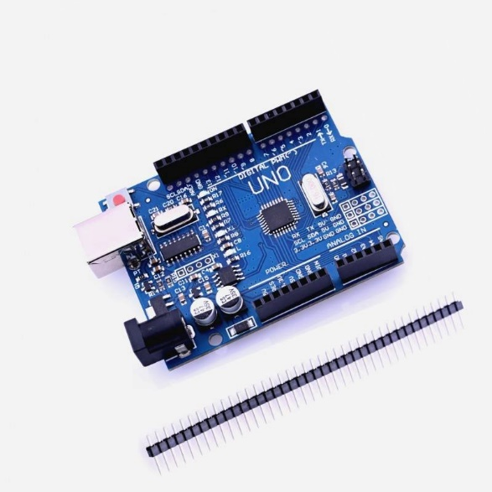The Arduino acts as the central nervous system for this innovative home automation project, bridging the gap between digital commands and physical actions. Through the code provided, it leverages defined pins such as ENA (3), in1 (4), in2 (7), and led (9) to enable fine-tuned control over a 5V DC motor and an LED light source.

Upon setup, the Arduino initializes the necessary components and communication channels. In the loop function, it continuously monitors the serial input from an external source, most likely a smartphone app via an HC-05 Bluetooth module. This input is interpreted to trigger specific actions based on the received values.

For instance, the Arduino processes input values ranging from 0 to 255 to modify the brightness of the connected LED using analogWrite(). Beyond lighting control, the code differentiates input values of 300 to 800 to manipulate the motor's behavior. Depending on these values, the Arduino skillfully toggles in1 and in2 states while applying pre-defined speed levels (ranging from speed1 to speed6) to ENA using analogWrite().

This orchestration allows users to finely adjust both LED illumination and fan speed, enhancing home comfort and ambiance. The Arduino's ability to interpret and execute commands from the code demonstrates its role as a dynamic controller, seamlessly integrating hardware and software to create a responsive and personalized home automation experience.

2)HC-05 Bluetooth Module

The HC-05 Bluetooth module serves as a wireless bridge in this project, enabling remote control of the Arduino. Linked to the Arduino, it establishes a Bluetooth connection that receives commands from a smartphone app. The code interprets these commands to adjust the LED's brightness and the 5V DC motor's speed. This compact module enhances user convenience, allowing personalized adjustments to the home environment. Through its role in facilitating seamless communication between the smartphone and the 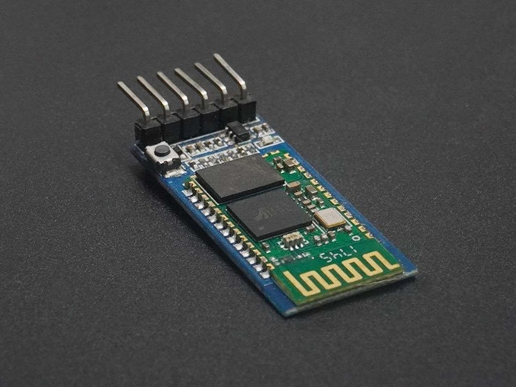Arduino, the HC-05 enriches the home automation experience, delivering responsive and adaptable control for improved comfort and ambiance.

It has 6 pins,

1. Key/EN: It is used to bring Bluetooth module in AT commands mode. If Key/EN pin is set to high, then this module will work in command mode. Otherwise by default it is in data mode. The default baud rate of HC-05 in command mode is 38400bps and 9600 in data mode.

HC-05 module has two modes,

a). Data mode: Exchange of data between devices.

b). Command mode: It uses AT commands which are used to change setting of HC-05. To send these commands to module serial (USART) port is used.

2. VCC: Connect 5 V or 3.3 V to this Pin.

3. GND: Ground Pin of module.

4. TXD: Transmit Serial data (wirelessly received data by Bluetooth module transmitted out serially on TXD pin)

5. RXD: Receive data serially (received data will be transmitted wirelessly by Bluetooth module).

6. State: It tells whether module is connected or not.

Specification of HC-05 Bluetooth Module

* Bluetooth version: 2.0 + EDR (Enhanced Data Rate)
* Frequency: 2.4 GHz ISM band
* Sensitivity: -80 dBm typical
* Range: approximately 10 meters (or 33 feet) in open air
* Profiles supported: SPP (Serial Port Profile), HID (Human Interface Device) and others
* Operating voltage: 3.3V to 5V DC
* Operating current: less than 50mA
* Standby current: less than 2.5mA
* Sleep current: less than 1mA
* Interface: UART (Universal Asynchronous Receiver/Transmitter)
* Baud rates: 1200, 2400, 4800, 9600, 19200, 38400, 57600, 115200, 230400, and 460800
* Operating temperature: -20°C to 75°C (-4°F to 167°F)

3)L298N Motor Driver

The L298N motor driver assumes a pivotal role in this project, aiding precise control of the 5V DC motor based on the provided code. Connected to pins ENA (3), in1 (4), and in2 (7), this module translates digital signals into adjustable motor speed and direction. Integrated with the Arduino, it executes commands from 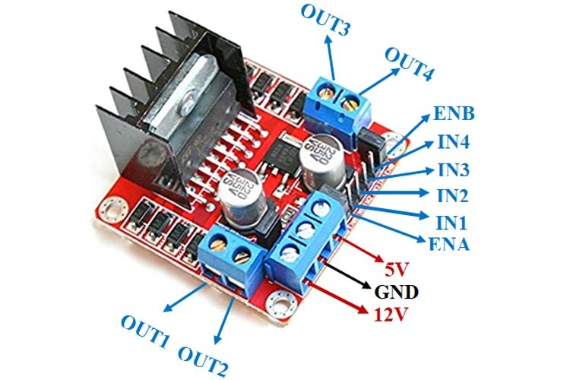the code to regulate the fan's speed and rotation direction. Its motor control capabilities optimize the 5V DC motor's performance, allowing for fluid adjustments and enhancing the overall home automation experience. Through its role in interpreting digital signals and powering the motor, the L298N motor driver seamlessly facilitates dynamic fan control in tandem with the project's code.

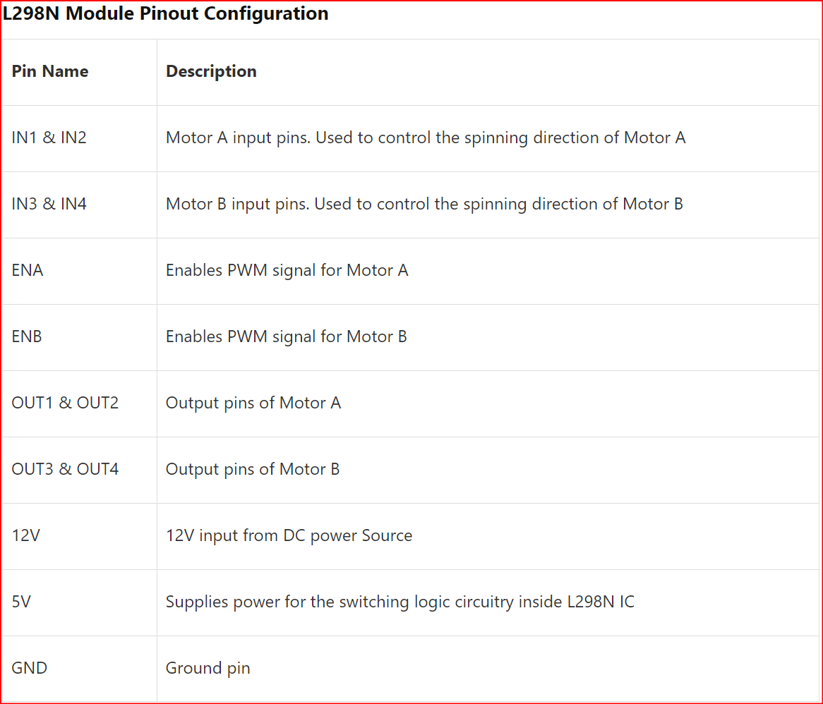

Features & Specifications

* Driver Model: L298N 2A
* Driver Chip: Double H Bridge L298N
* Motor Supply Voltage (Maximum): 46V
* Motor Supply Current (Maximum): 2A
* Logic Voltage: 5V
* Driver Voltage: 5-35V
* Driver Current:2A
* Logical Current:0-36mA
* Maximum Power (W): 25W
* Current Sense for each motor
* Heatsink for better performance
* Power-On LED indicator

4)Resistor(1K)

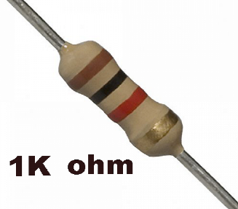Resistors are crucial components in this project, establishing precise current flow for various elements as defined in the provided code. These components help regulate the voltage levels across different components, ensuring proper functioning of devices such as LEDs, motors, and Arduino pins (ENA, in1, in2, led). By limiting or adjusting the flow of electric current, resistors contribute to stable and efficient performance of the entire system.

5)LED

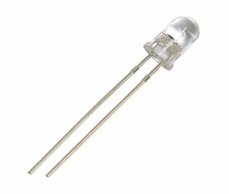The LED, connected to pin 9, is a core element of this project. Controlled through analogWrite(), it adjusts its brightness based on input values from the code. These values, ranging from 0 to 255, offer dynamic lighting customization. This LED integration elevates the home automation experience, enabling personalized ambiance adjustments to complement the project's comprehensive functionalities.

6)Jumper Wires

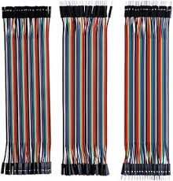Jumper wires are essential for connecting components in this project. They establish connections between the Arduino pins (ENA, in1, in2, led) and other components. Their flexibility and simplicity enable the seamless integration of hardware elements, ensuring data and power transmission in accordance with the provided code.

7)PCB

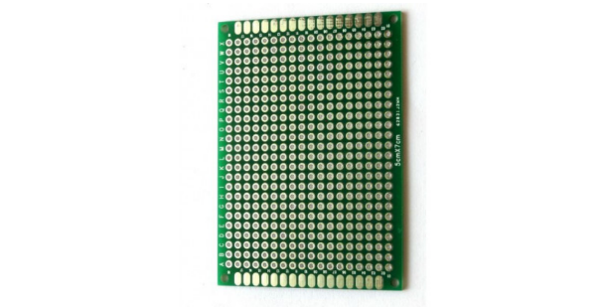A PCB (Printed Circuit Board) simplifies the interconnection of components in this project, streamlining the layout defined by the provided code. Components like Arduino pins (ENA, in1, in2, led) and wires are soldered onto the PCB, ensuring stable connections. PCBs enhance reliability, reduce clutter, and facilitate efficient circuitry, fostering a cohesive integration of hardware elements.

8)DC Motor(5V)

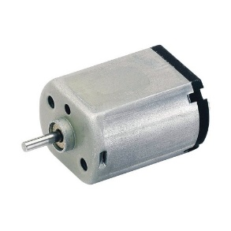The 5V DC motor, designed for 5-volt power sources, serves as a pivotal element in the home automation project. Its variable speed, regulated through PWM signals, ensures precise fan control. Operating within 100-300mA current limits, it aligns with microcontroller capacities. The motor's shaft facilitates mechanical attachment while interfacing with the L298N motor driver, enabling seamless integration with the Arduino Uno. This motor plays a crucial role in realizing adjustable fan speeds, enhancing user comfort and home automation efficiency.

**Back-End Code of Application**

MIT App Inventor is a powerful visual programming environment that complements this project's hardware setup. By creating a smartphone application using MIT App Inventor, users establish a wireless connection to the Arduino via the HC-05 Bluetooth module. This app allows users to send commands, such as adjusting LED brightness and fan speed, as specified in the provided code. The user-friendly interface enables efficient customization of home ambiance and fan control, enhancing user comfort and convenience. MIT App Inventor bridges the gap between code and user interaction, contributing to a comprehensive home automation experience.

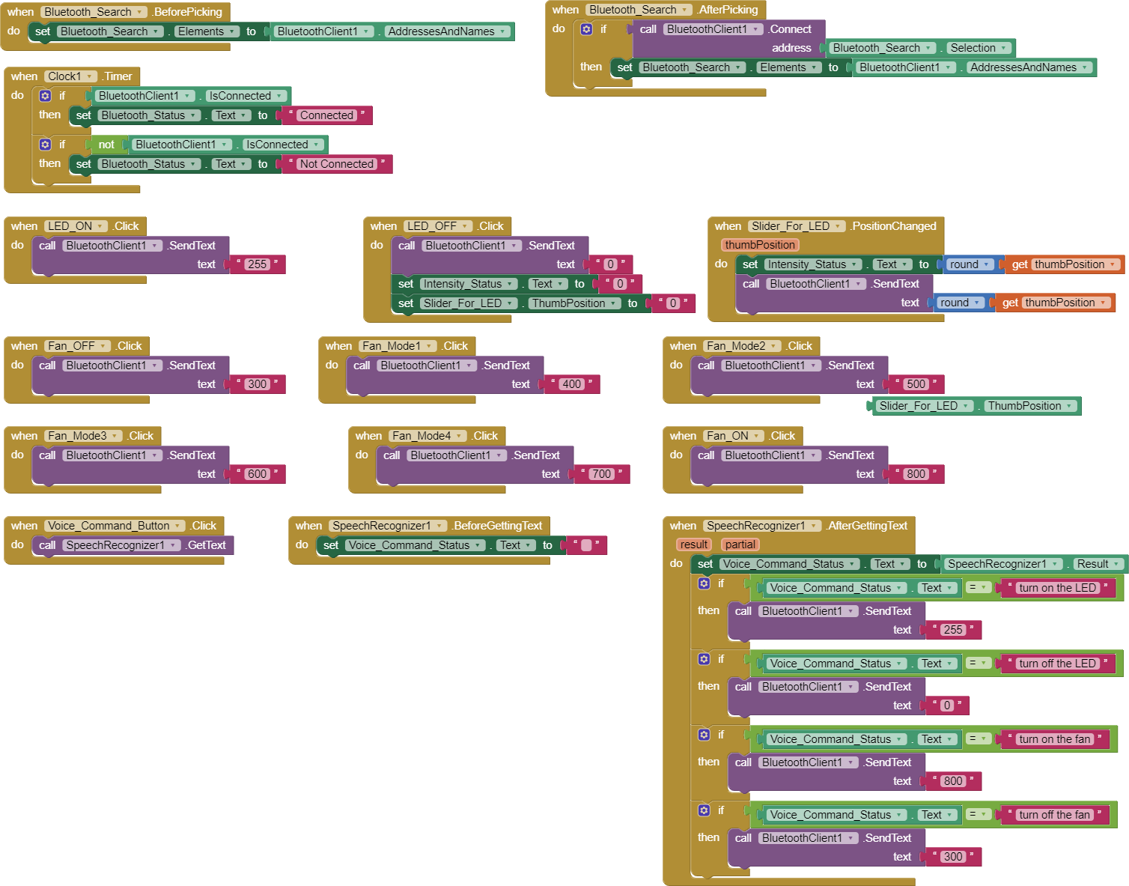

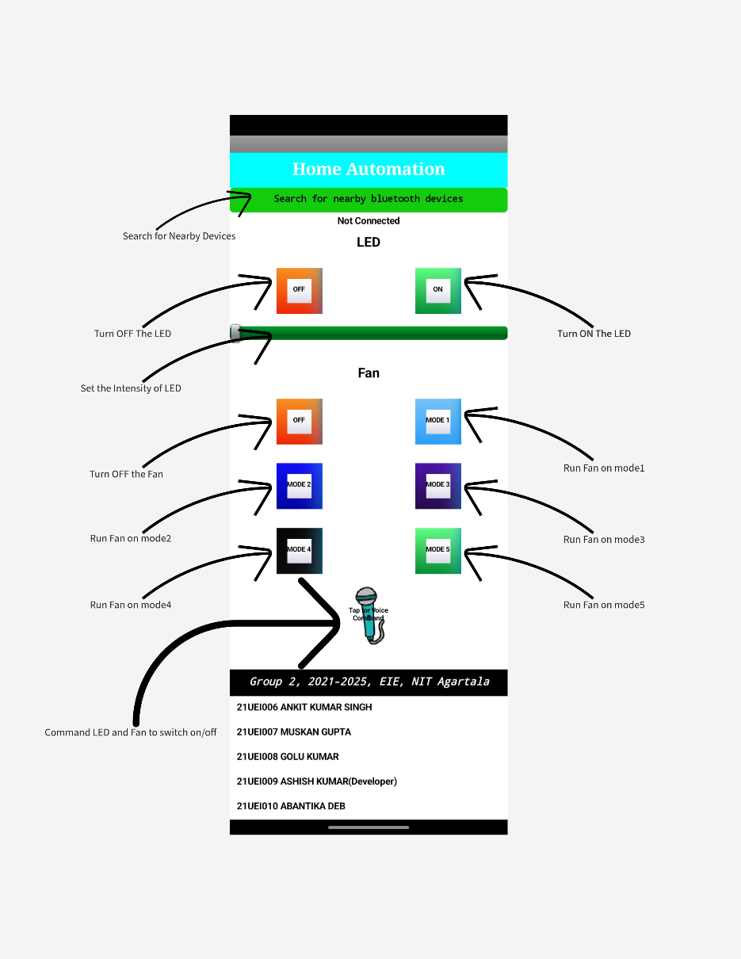**Application Interface**

**Arduino Code**

#define ENA 3

#define in1 4

#define in2 7

#define led 9

int speed1=0;

int speed2=51;

int speed3=102;

int speed4=153;

int speed5=204;

int speed6=255;

int i;

void setup() {

Serial.begin(9600);

pinMode(ENA,OUTPUT);

pinMode(in1,OUTPUT);

pinMode(in2,OUTPUT);

pinMode(led,OUTPUT);

}

void loop()

{

while(Serial.available()>0)

{

i=Serial.parseInt();

if(i>=0&&i<=255){

analogWrite(led,i);

}

else if(i==300){

digitalWrite(in1,LOW);

digitalWrite(in2,HIGH);

analogWrite(ENA,speed1);

}

else if(i==400){

digitalWrite(in1,LOW);

digitalWrite(in2,HIGH);

analogWrite(ENA,speed2);

}

else if(i==500){

digitalWrite(in1,LOW);

digitalWrite(in2,HIGH);

analogWrite(ENA,speed3);

}

else if(i==600){

digitalWrite(in1,LOW);

digitalWrite(in2,HIGH);

analogWrite(ENA,speed4);

}

else if(i==700){

digitalWrite(in1,LOW);

digitalWrite(in2,HIGH);

analogWrite(ENA,speed5);

}

else if(i==800){

digitalWrite(in1,LOW);

digitalWrite(in2,HIGH);

analogWrite(ENA,speed6);

}

Serial.print("Received value: ");

Serial.println(i);

}

}

**Circuit Diagram**

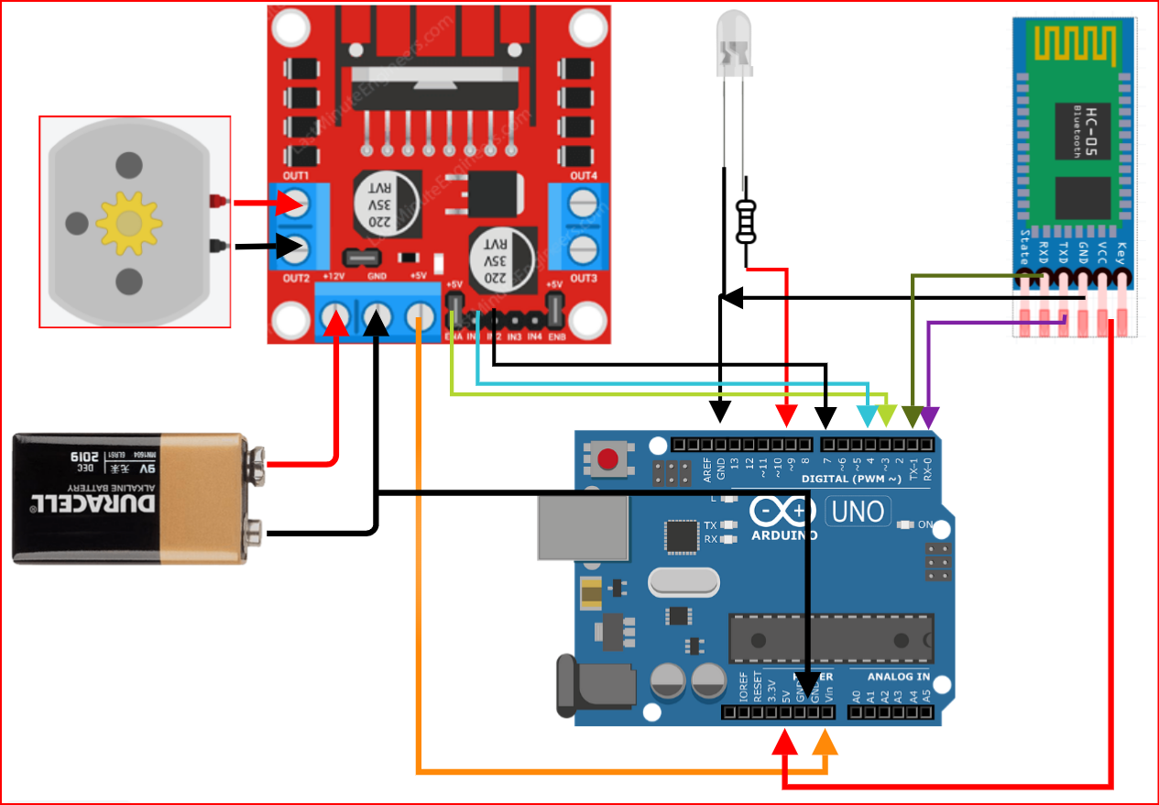

**Benefits**

* Convenience: Users can manage their home environment remotely, enhancing comfort and energy efficiency.
* Customization: The system allows personalized control over lighting and ventilation, contributing to a tailored living experience.
* Technological Learning: Implementing this project offers valuable insights into Arduino programming, Bluetooth communication, and mobile application development.
* Cost-Efficiency: The project provides an economical solution for home automation compared to commercial alternatives.
* Integration Potential: This project can serve as a foundation for expanding the home automation network to include additional devices and functionalities.

**Conclusion**

The Smartphone-Controlled Home Automation System utilizing Arduino Uno, HC-05, and MIT App Inventor represents a leap forward in smart living. By integrating these technologies, users gain the power to control their home environment effortlessly and efficiently, all from the palm of their hand.

**-------------------**